1. Try out the .to_f operation. What does .to_f do?

The [.to_f method](http://ruby-doc.org/core-2.2.0/String.html#method-i-to_f) on a string returns the interpretation of the leading characters as a floating point number. Characters past the valid number characters are ignored. If no valid number is found at the beginning of the string, 0.0 will be returned.

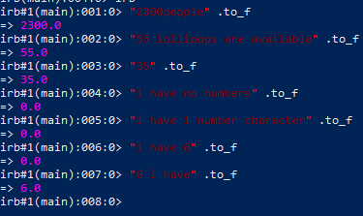

1. To play with .to_f more, make a small script that asks for some money and gives back 10% of it. If I give your script 103.4 (dollars), your script gives me back 10.34 in change.

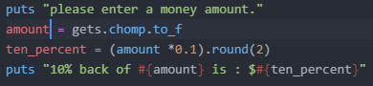

Output:

